## horizontal line

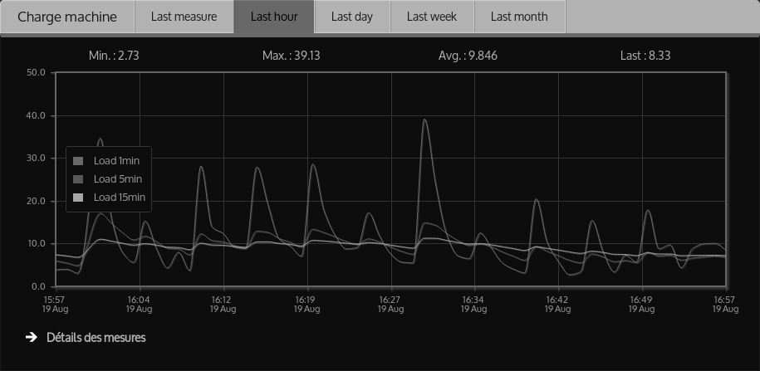

Web based Network Monitoring Tool using Django

08.03.2017

**─**

# TEAM MEMBERS

* Shivam Kapoor

15BCE1339

* Abhishek Singh

15BCE1009

# OVERVIEW

A Network monitoring is the heart of a server. Network Monitoring tool is needed when system analyst needs the data in figures and graphs and want to analyze the nodes connected. Through this network monitoring tool, one will be able to analyze the whole server and it’s CPU Usage, Packets deliverance, Connections, Bandwidth, Memory and many more things. This will work on Django Framework with python scripting with web based front end.

# MODULES INCLUDED

The Project will have the following major modules included -

1. Server monitoring - Monitor packet loss, response time and performance metrics of the nodes connected.
2. Bandwidth analysis - Analyse the bandwidth consumed by each node on the network.
3. Memory usage - Graph and pie chart for memory management.
4. CPU management - Displays graphs and pie chart for the CPU usage.
5. Other modules - Options for adding a server into the network, idle time of every server, load management etc.

# LIBRARIES AND APPLICATIONS USED

The Project will use the following libraries, applications and packages -

1. SSH python library
2. jQuery plotting and charting library
3. Responsive html, css, js bootstrap
4. Django application
5. Django kronos
6. Django extra views
7. Numpy python library

# ALGORITHMS USED

The Project will work on some set of algorithms to make the tool efficient and accurate in real time -

**1). Variable packet size algorithm :**

This algorithm will be used estimating link capacity. This algorithm includes size differential (SD) and hop differential (HD) methods for estimating the transfer rate of packets.

**2). Packet pair dispersion :**

This algorithm will be used analyse the bottleneck link capacity. As, if a pair of packet travels back to back through a bottleneck link, the last bits of the two packets are further separated. After they leave the bottleneck link, this separation will remain till the destination. So, the packet pair dispersion represents the narrow link’s capacity.

**3). OWD algorithms :**

This algorithm will be used detect one way delay to measure the available bandwidth.

**4). Feedback adaptive control algorithm :**

As the name defines it would be used to address a packet’s accuracy and non intrusiveness.

# FINAL DELIVERABLES

Final Deliverables include Network Monitoring Tool executable files which can be installed on various platform. Also we will make our project open source on github :). Documents and Reports will be submitted after last review.